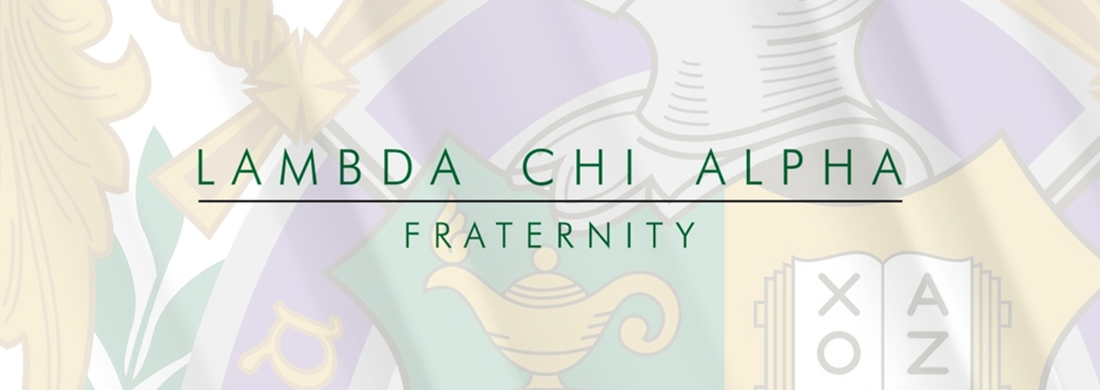
Dear Lambda Chi Alpha Parents,

Welcome to the family! The young men of our chapter, the alumni, and the international headquarters of Lambda Chi Alpha would like welcome you and your family into ours. Internationally, chapters of Lambda Chi Alpha exemplify the highest standards of their members. Our chapter here at Miami University of Ohio is no different. You and your son are taking the first of many wonderful steps in becoming an active part of the family of Lambda Chi Alpha.

Lambda Chi Alpha was first founded in 1909 at Boston University. The founder, Warren Cole, began Lambda Chi Alpha through the reorganization of a group of law students. The group would grow, merge with other organizations, and eventually becoming one of the largest chapters in the United States with over 280,000 members. It was founded upon principles of high standards. Lambda Chi Alpha was the first general fraternity to abolish hazing.

As your son progresses through our new member education he will receive teaching on our seven core values. These include: loyalty, duty, respect, service and stewardship, honor, integrity, and personal courage. These values are at the heart of every Lambda Chi Alpha member and are the basis for how we operate and treat each other. We are proud of our positive culture and strive to stand out as gentlemen of value in our community.

We encourage you to take as much of an interest to our chapter as possible. Whether it be contributing to our philanthropy, attending our mothers and fathers weekends, calling and asking your son about his experience thus far, or even as simple as following us on social media. Never hesitate to reach out. We look forward to the experiences to come.

Sincerely,
Alec Glynn – Chapter President – (262) 510-9511
Max Steinbach – Chapter Vice President - (516) 477-6275
Jacob Wehr – New Member Educator – (614) 517-3384
David Steinman – Greek Advisor – (847) 951-2041
Grant Zehnder- IFC President - (440) 714-7958
Miami University Hazing Policy:
Code of Student Conduct—2.1.I Hazing
Coercing another, including the victim, to do any act of initiation into, or as a condition of participation in, a student organization, fraternity or sorority, or activity that causes or creates a substantial risk of causing physical or mental harm to any person is prohibited. Examples of prohibited behavior include forced drinking of alcohol or water, paddling, creation of fatigue, physical shocks, degrading or humiliating games, physical harassment, branding, public stunts, and forced tattoos.

Lambda Chi Alpha National Anti-Hazing statement
In the 1970s, Lambda Chi Alpha was the first international fraternity to abandon hazing. Lambda Chi Alpha decided to take a stance against the practice and instead implement a respect based new member education. This goes from the top down and is a belief all chapters share. Hazing is not tolerated and never will be.

Our chapter’s stance on hazing
Our chapter fully supports and respects our national hazing stance. Furthermore, we seek to be a shining light on Miami University’s campus and help lead greek life to a more respectable, and sustainable future. We believe in our Associate Members and treat them with respect. This is why we call them Associate Members instead of pledges. Our chapter does not tolerate hazing whatsoever and we seek to hold the highest standard of our young men.

We define hazing as any act or any action taken or situation created, intentionally,
whether on or off Fraternity premises, to produce mental or physical discomfort, embarrassment, harassment or ridicule. This includes but is not limited to forced consumption, includes paddling in any form; creation of excessive fatigue; physical and psychological shocks; quests, treasure hunts, scavenger hunts, road trips or any other such activities carried on outside the confines of the house; wearing, publicly, apparel which is conspicuous and not normally in good taste; engaging in public stunts and buffoonery; morally degrading or humiliating games and activities, late work sessions which interfere with scholastic activities and any other activities which are not consistent with the United States Constitution, Ohio State law, Miami University policy and fraternal bylaws or policy.

